Mobile App Prototype
Mahmudul Alam
Colorado State University Global
20WA-CSC505-1
Wednesday, December 23, 2020

A mobile app is an application that can be accessed by a user, a personalized version. User can have data and preferences related to specific user type and user information. We are trying to build an app that will help the users to make lists and track their lists. We are going to build a IOS based system for this mobile application. The name of the application is “Record My Items” there will be multiple pages associated with the app. There will be the login page which is the most important part of the application. Overall follow chart for the application is as follows
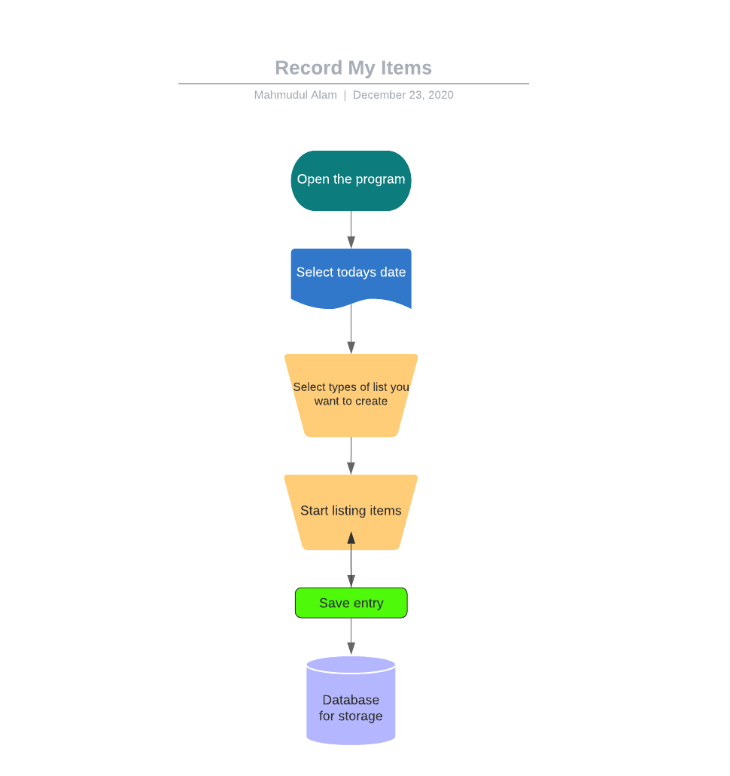

Our main purpose is to have a personalized version therefore we are going to require the users to login. Validating user login information can be done using the following diagram.
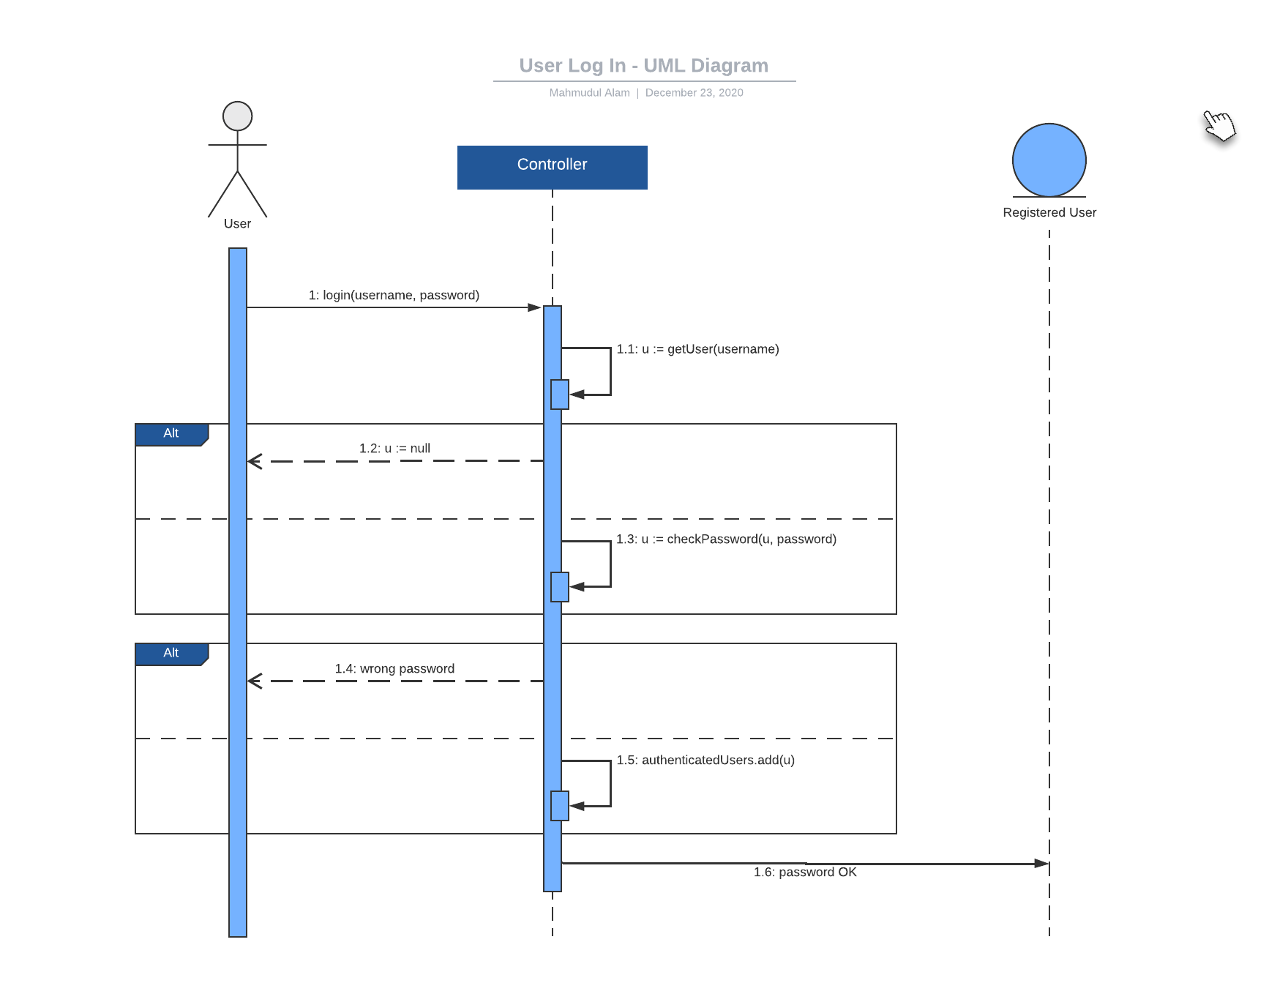
Once the user has inputted the items, they want to record we are going to store that information a cloud-based system. To reduce costs, increase agility, and accelerate innovation, AWS provides a full range of services for you to store, view, monitor, and analyze your data. To create the foundations of your cloud IT environment, choose from object storage, file storage, and block storage services, backup, and data migration options. According to AWS DataSync “AWS DataSync makes it easy to move data over the network between on-premises storage and AWS Storage services, as well as between AWS Storage services.” AWS have many other IT services like user login data validation, security for the app and other IT support which we are considering for the development of this application.
According to Thunderquote “The future of mobile is the future of online. It is how people access online content now.” It is important for us to remember how important an application is for our current society. There is no room for mistakes while building an app and we must make sure the user is happy with the product if we want to continue develop the product. We also must make sure we are using the latest services and UI for our application to have better chance for succeeding.

References
AWS DataSync. (n.d.). Retrieved from https://aws.amazon.com/datasync/?c=s&sec=srv&whats-new-cards.sort-by=item.additionalFields.postDateTime&whats-new-cards.sort-order=desc © 2020, Amazon Web Services, Inc. or its affiliates. All rights reserved.
Thunderquote. (1970, May 25). 10 Inspiring Quotes on Mobile App Design. Retrieved December 23, 2020, from https://blog.thunderquote.com/2017/03/21/10-inspiring-quotes-on-mobile-app-design/

